Epsom & Ewell
8
v
Frimley Green
Saturday, 3rd November 2018 – 3.00 p.m.
Good afternoon! We welcome the players, supporters and officials of Frimley Green to High Road for an important League match. Their last visit came on the occasion of Lyndon Buckwell’s last match in charge of the club on 13th September 2014 and resulted in a 0-0 draw, with a rare penalty miss from Kyle Hough proving costly that day.

Frimley had a tough season that year and went down, residing at Step Six ever since, while we of course suffered the same fate last year. Both are in the mix for promotion this term though, so we should witness a committed encounter between the two teams.

We were last at High Road eleven days ago when we hosted Knaphill Under 23s in our first ever Surrey Premier Cup match and won comfortably by five clear goals. Bobby Bennett and Rob Hendry both scored twice with Theo Campbell scoring his first for the club also. Bennett now has six penalties this season and is very close to overhauling a record I thought would last for many years; that of penalties in a season. Regular striker and club legend Kyle Hough scored nine on three occasions so that mark is well within reach right now, even if his overall tally of 55 is not yet on the horizon! We now host Dorkinian F.C. in the last 16.

We then visited Chalky Lane on Saturday for a League meeting with our local rivals Chessington & Hook United and when we trailed with ten men I feared the worst, yet somehow we fought back in spectacular style, scoring four goals to win 4-1! This really was an amazing turnaround, unprecedented in club history and hopefully we can use that result as a springboard for the remainder of the season, starting today.

We are back here again on Tuesday as Sandhurst Town visit us for a Division One Cup tie. A win would take us into the Quarter-Finals and it is worth noting that of the top sides in our division Farnham Town and Dorking Wanderers Reserves are already out of this competition.

We then visit Ash United on Saturday before we return here for our first ever meeting with Kensington Borough two weeks today.

Why not come along and follow the Salts as we need your support!

Enjoy the game!

Rich

You can follow us on Facebook: www.facebook.com/epsomandewellfc
Twitter: @EEFCOfficial Instagram at: www.instagram.com/epsomandewellfc
and Youtube at: www.youtube.com/channel/UCtLrpS0x5OaYUACRT34_zng

Cover photo by Gemma Jarman

- Lloyd Connelly puts us 2-1 up at Chessington & Hook United with a header
- Bobby Bennett scores our equaliser just before half time in that match
- Bobby Bennett wraps up the scoring in injury time as he rounds the keeper

Cherry Red Records Combined Counties League
Division One Table 2018/19
inc Tuesday 30th October 2018 | P | W | D | L | F | A | Pts | GD | H | A
Farnham Town | 14 | 9 | 3 | 2 | 32 | 12 | 30 | +20 | 2/2 | 1-4
Sheerwater | 14 | 9 | 3 | 2 | 34 | 19 | 30 | +15 | 2-3 | 22/12
AC London | 14 | 9 | 2 | 3 | 35 | 23 | 29 | +12 | 2/3 | 6-0
Bedfont & Feltham | 11 | 8 | 3 | 0 | 41 | 9 | 27 | +32 | 8/12 | 13/4
Frimley Green | 13 | 7 | 5 | 1 | 24 | 16 | 26 | +8 | 3/11 | 23/2
Dorking Wanderers Res | 14 | 7 | 4 | 3 | 34 | 26 | 25 | +8 | 27/11 | 3-5
Epsom & Ewell | 13 | 8 | 0 | 5 | 36 | 23 | 24 | +13 | X | X
Ash United | 13 | 6 | 4 | 3 | 36 | 27 | 22 | +9 | 12/1 | 10/11
British Airways | 15 | 6 | 3 | 6 | 32 | 33 | 21 | -1 | 16/2 | 2-3
Sandhurst Town | 12 | 6 | 3 | 3 | 21 | 23 | 21 | -2 | 20/4 | 2-0
Chessington & Hook Utd | 14 | 6 | 1 | 7 | 25 | 29 | 19 | -4 | 1-2 | 4-1
Tooting Bec | 13 | 5 | 2 | 6 | 26 | 24 | 17 | +2 | 3-1 | 30/3
Godalming Town | 12 | 3 | 2 | 7 | 15 | 25 | 11 | -10 | 1/12 | 26/1
Kensington Borough | 13 | 3 | 2 | 8 | 21 | 32 | 11 | -11 | 17/11 | 9/3
Eversley & California | 11 | 3 | 0 | 8 | 18 | 27 | 9 | -9 | 29/12 | 24/11
Fleet Spurs | 12 | 3 | 0 | 9 | 19 | 31 | 9 | -12 | 6/4 | 3-2
Bagshot | 14 | 2 | 2 | 10 | 12 | 52 | 8 | -40 | 19/1 | 3-0
FC Deportivo Galicia | 12 | 1 | 2 | 9 | 12 | 23 | 5 | -11 | 12/3 | 3-0
Cove | 12 | 1 | 1 | 10 | 16 | 35 | 4 | -19 | 3-2 | 5/1

Lucky Day? – 3rd November
Played 15 - Won 7 Drawn 1 Lost 6 - For 44 Against 33 - PPG 1.57 - Above Average
Our Club record against Frimley Green
Played 10 - Won 8 Drawn 1 Lost 1 - For 32 Against 5 - PPG 2.50 - Fantastic
Biggest wins and losses against Frimley Green
26th January 1982 - W 7-1 - Southern Combination Cup (A) - at West Street
24th November 1973 - L 0-1 - Surrey Senior League (H)
Frimley Green‘s last visit
Saturday, 13th September 2014 - Drew 0-0 - Combined Counties League

First Eleven Appearances 2018/19 - (max 19)
Name | Debut | 2018/19 |  |  |  | Career Totals
 |  | App | Sub | Tot | Goals | App | Sub | Tot | Goals
BENNETT Bobby | 12/08/2018 | 14 | 0 | 14 | 11 | 14 | 0 | 14 | 11
BETANCOURT Steve | 18/08/2018 | 15 | 1 | 16 | 1 | 15 | 1 | 16 | 1
BORRETT Ricky | 04/08/2018 | 9 | 0 | 9 | 0 | 9 | 0 | 9 | 0
CAMPBELL Kieran* | 29/09/2012 | 7 | 3 | 10 | 2 | 59 | 3 | 62 | 2
CAMPBELL Theo | 28/08/2018 | 2 | 9 | 11 | 1 | 2 | 9 | 11 | 1
CAULCRICK Joshua | 17/02/2018 | 0 | 3 | 3 | 0 | 0 | 4 | 4 | 0
CONNELLY Lloyd | 14/10/2017 | 19 | 0 | 19 | 4 | 49 | 4 | 53 | 5
DOBRAJ Endrit | 18/11/2017 | 5 | 2 | 7 | 1 | 24 | 6 | 30 | 1
DYSON Ben* | 12/08/2017 | 0 | 1 | 1 | 0 | 28 | 14 | 42 | 2
ELGAR Luke | 04/08/2018 | 2 | 3 | 5 | 1 | 2 | 3 | 5 | 1
ELGAR Scott | 12/08/2018 | 3 | 6 | 9 | 0 | 3 | 6 | 9 | 0
GAFFNEY Luke | 16/08/2014 | 2 | 0 | 2 | 0 | 12 | 1 | 13 | 0
GILL George | 28/08/2018 | 2 | 0 | 2 | 0 | 2 | 0 | 2 | 0
GRIFFIN Reisse | 08/08/2015 | 11 | 0 | 11 | 2 | 115 | 13 | 128 | 10
HEAGNEY Adam | 16/08/2016 | 19 | 0 | 19 | 0 | 86 | 13 | 99 | 2
HENDRY Rob | 08/08/2015 | 4 | 0 | 4 | 3 | 88 | 23 | 111 | 31
JEANNOEL Germaine | 02/12/2017 | 0 | 4 | 4 | 2 | 2 | 11 | 13 | 3
JONES David | 31/08/2018 | 3 | 2 | 5 | 0 | 3 | 2 | 5 | 0
LOFTUS-CHEEK Joe | 06/08/2017 | 0 | 1 | 1 | 0 | 14 | 8 | 22 | 6
MARTINEZ Oliver | 29/09/2018 | 3 | 1 | 4 | 1 | 3 | 1 | 4 | 1
MCKAY Alex | 20/12/2008 | 1 | 0 | 1 | 0 | 163 | 39 | 202 | 13
MORGAN Sam | 11/09/2018 | 1 | 2 | 3 | 0 | 1 | 2 | 3 | 0
MURPHY Scott | 20/01/2007 | 19 | 0 | 19 | 2 | 66 | 2 | 68 | 6
ROBERTS Liam | 12/08/2017 | 15 | 1 | 16 | 7 | 36 | 15 | 51 | 12
SMITH Taryn | 28/10/2017 | 6 | 6 | 12 | 5 | 14 | 10 | 24 | 5
SULLIVAN Ryan | 04/08/2018 | 11 | 1 | 12 | 0 | 11 | 1 | 12 | 0
SUTHERLAND Mitchel | 04/08/2018 | 1 | 1 | 2 | 0 | 1 | 1 | 2 | 0
THOMPSON Elliott | 09/02/2016 | 15 | 1 | 16 | 0 | 25 | 10 | 35 | 1
WHITE Sean | 02/08/2014 | 9 | 4 | 13 | 4 | 29 | 25 | 54 | 9
WOODCOCK Josh | 22/09/2018 | 1 | 0 | 1 | 0 | 1 | 0 | 1 | 0
WRIGHT Kieran* | 15/09/2018 | 3 | 3 | 6 | 0 | 3 | 3 | 6 | 0
YOUNG Conor | 07/03/2015 | 7 | 0 | 7 | 0 | 40 | 0 | 40 | 0
* - Player has left the club

Recent Results and Fixtures
Surrey Premier Cup 2nd Round – Tuesday 23rd October
Alfold | 2-0 | Godalming Town
Epsom & Ewell | 5-0 | Knaphill U23
Combined Counties League – Tuesday 23rd October
Dorking Wanderers Reserves | 1-2 | Sheerwater
Surrey Premier Cup 2nd Round – Wednesday 24th October
Reigatians @ South Park FC | 0-4 | Frimley Green
Met Police Reserves | p-p | FC Deportivo Galicia
Combined Counties League – Saturday 27th October
British Airways | 5-1 | Dorking Wanderers Reserves
Chessington & Hook United | 1-4 | Epsom & Ewell
Cove | 2-0 | Godalming Town
Eversley & California | 1-3 | Sheerwater
Farnham Town | 0-1 | AC London
Frimley Green | 3-0 | Bagshot
Kensington Borough | 0-1 | Fleet Spurs
Sandhurst Town | 1-0 | FC Deportivo Galicia
Tooting Bec | 2-3 | Ash United
Esoteric Division One Cup 2nd Round – Tuesday 30th October
Fleet Spurs | 0-0+ | Cove
Fleet Spurs won 4-3 on penalties
Godalming Town | 6-0 | Bagshot
Buildbase F.A. Vase – Second Round – Saturday 3rd November
Kensington Borough | V | Erith Town
Combined Counties League – Saturday 3rd November
AC London | V | Sandhurst Town
Bedfont & Feltham | V | Dorking Wanderers Reserves
Chessington & Hook United | V | British Airways
Epsom & Ewell | V | Frimley Green
Farnham Town | V | Tooting Bec
FC Deportivo Galicia | V | Bagshot
Fleet Spurs | V | Eversley & California
Sheerwater | V | Cove
Esoteric Division One Cup 2nd Round – Tuesday 6th November
Epsom & Ewell | V | Sandhurst Town
Sheerwater | V | Cove
Combined Counties League – Tuesday 6th November
Ash United | V | FC Deportivo Galicia
Eversley & California | V | Dorking Wanderers Reserves
Recent Results and Fixtures
Combined Counties League – Tuesday 6th November
Chessington & Hook United | V | British Airways
Kensington Borough | V | Bagshot
Combined Counties League – Saturday 10th November
Ash United | V | Epsom & Ewell
British Airways | V | Tooting Bec
Cove | V | Bagshot
Dorking Wanderers Reserves | V | Frimley Green
Eversley & California | V | Chessington & Hook United
Farnham Town | V | FC Deportivo Galicia
Fleet Spurs | V | Godalming Town
Kensington Borough | V | Bedfont & Feltham
Sandhurst Town | V | Sheerwater
Combined Counties League Cup – Second Round – Monday 12th November
Sutton Common Rovers |  | Southall
Combined Counties League Cup – Second Round – Tuesday 13th November
CB Hounslow United | V | Badshot Lea
Chertsey Town | V | British Airways
Cobham | V | AFC Hayes
Hanworth Villa | V | Sandhurst Town
Esoteric Division One Cup 2nd Round – Tuesday 13th November
Kensington Borough | V | FC Deportivo Galicia
Combined Counties League – Tuesday 13th November
Godalming Town | V | Kensington Borough
Combined Counties League – Saturday 17th November
Bagshot | V | Dorking Wanderers Reserves
Bedfont & Feltham | V | Cove
Chessington & Hook United | V | AC London
Epsom & Ewell | V | Kensington Borough
FC Deportivo Galicia | V | Eversley & California
Frimley Green | V | Ash United
Godalming Town | V | Farnham Town
Sheerwater | V | Fleet Spurs
Tooting Bec | V | Sandhurst Town
Combined Counties League – Saturday 24th November
Eversley & California | V | Epsom & Ewell
Combined Counties League – Tuesday 27th November
Epsom & Ewell | V | Dorking Wanderers Res

From behind the goal
British Airways 3-2 Epsom & Ewell
Combined Counties League - Wednesday 10th October 2018

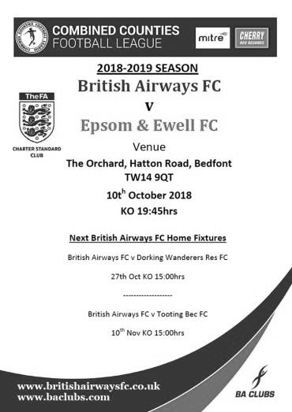
Salts let three points slip away to BA

Our fourth league defeat of the season came at the Orchard, home of Bedfont & Feltham as we led twice but were defeated 3-2 for the second time in a row, and this time it was to Middlesex League Champions and Combined Counties League new boys British Airways.

If you exclude the Chessington loss where we played much of the match with ten men, the other three League defeats have followed a similar pattern as we have led in all of them, only to concede goals in the last ten minutes in each case. This latest defeat even contained two Salts leads and an even later winning goal, but make no mistake here, once again we didn't do enough to deserve the points and it was only wasteful finishing from the opposition that kept the scores even for so long, although we also missed earlier chances that might have made our evening's work a little more straightforward.

If we have a defence for these latest results, injuries could be it. Already missing two regulars with broken bones, both Adam Heagney and Scott Murphy were forced off during this match and have to also be rated as doubtful for our enormous match in ten days at Farnham Town. We did have a re-appearance from Rob Hendry in this match as we looked to fill the centre-forward position, but he looked rusty and will take a bit of time to get into things once again, although we know Hendo to be a solid acquisition that will strengthen the team.

In fact, we lined up with a fairly strong looking eleven, albeit with only three substitutes and Kieran Wright came in for another injured player in Endrit Dobraj while Hendry replaced the absent Liam Roberts. Despite this we nearly conceded twice in the opening two minutes. A low shot from tricky striker Chris Baah forced Conor Young into a good low save after just 55 seconds and from the subsequent corner, a strike on goal was then blocked on the line by Steve Betancourt. Despite this, we probably should have gone in front in the third minute ourselves when a clever pass found Olly Martinez in a central position and with just the keeper to beat, but he clipped his shot inches wide of Perry Cheadle's right hand post from twelve yards.

The game swung from end to end and we had a major warning when Baah broke through our offside trap but Young made a great save from the one-on-one situation with just a quarter of an hour played, while for us Hendry was first to reach an Elliott Thompson corner but his near post header wasn't delicate enough and the ball sailed over the bar.

Unfortunately Heagney then hurt his shoulder badly and was replaced by Scott Elgar so in the 28th minute he wasn't around to take a free kick in a dangerous position. Hendry took it instead and from twenty yards he pinged the ball onto the Airways crossbar and up in the air but we weren't able to reach the ball as it fell and a defender cleared the danger for a corner that came to nothing.

However, we did manage to break through in the 32nd minute in unusual circumstances. A Martinez left wing cross was delivered deep to the far post and it dropped for Bobby Bennett, just three yards out but at a slightly wide angle. He saw Hendry standing in a better position and tried to square the ball to him, but instead the ball skewed off his leg at a completely different angle which wrong footed the keeper and crept just inside the near post!

We nearly extended the lead when a Hendry corner was nearly met by Murphy but his attempt was blocked and he got kicked in the process. While he was lying on the goal line however, we kept playing and a low shot in was then tipped wide by Cheadle. Murphy re-joined the action after treatment but would be unable to start the second half. In the time that remained there was a chance at either end, firstly when a long kick from Young was latched onto by Hendry but he dragged his shot wide from 12 yards. Then at the other end Daniel Kusimo rode two weak challenges and smashed the ball past Young for the equaliser in first half injury time.

Maybe we should have been further ahead by this point, but the simple facts were that the opposition were back in it and sensing vulnerability, they grew in confidence. Young made a good low save after our offside trap was broken again before a dangerous ball from their left wing went straight across our six yard area. In response Betancourt was unable to direct his effort from Hendry's corner on target. However, there was more concern as they broke away from this and had Martinez not taken one for the team in pulling their man back we could have been in more trouble.

In the 57th minute Martinez was involved again, but this time to provide his second assist of the match, slightly against the run of play. David Jones had come on for the injured Murphy which released new Captain Reisse Griffin forward and his run across the defender was perfectly timed with a superb cross and his close range header gave Cheadle no chance.

Could we hold on this time? Regrettably not. A Lloyd Connelly header back into the danger area nearly marred his 50th appearance but the opposition striker found his shot deflected wide for a corner. Still the warnings weren't heeded and in the 65th minute Lewis Nobes broke our offside trap and strolled in on goal, finishing off past Young to secure the second equaliser.

We looked really ragged at the back in this match but still looked capable of scoring at the other end, and another Martinez cross nearly provided a third goal when his low ball in was sliced wildly by the home Captain Craig Jeff, but the ball went straight at Cheadle when it could have gone anywhere! Baah picked up a booking for diving in the penalty area before we threatened once again with Hendry's curling low right wing delivery, although it had just too much on it for substitute Germaine Jeannoel and the ball went out for a goal kick only a few feet beyond the far post.

We had another scare in the 85th minute when Jones tried to head the ball back to Young but the ball was intercepted with our keeper repelling the danger with a smart save, giving defenders time to recover and hack the ball clear. However, in the 88th minute a straightforward left wing cross was met by the unmarked Nobes who scored his second goal of the match with a downward header that again gave Young no chance.

So another match slipped away from a winning position and in similar circumstances to previous ones, which indicates that we are not learning the lessons of those previous defeats. For the second match in a row we were unable to take advantage of good fortune and right now our plan to return to the Premier Division at the first time of asking is looking ambitious, if not yet impossible.

Epsom and Ewell: Conor Young, Kieran Wright, Reisse Griffin, Lloyd Connelly, Steve Betancourt, Adam Heagney, Bobby Bennett, Scott Murphy (c), Rob Hendry, Elliott Thompson, Olly Martinez

Subs: Scott Elgar for Heagney (27), David Jones for Murphy (46),
Germaine Jeannoel for Wright (71)

From behind the goal
Farnham Town 4-1 Epsom & Ewell
Combined Counties League - Saturday 20th October 2018

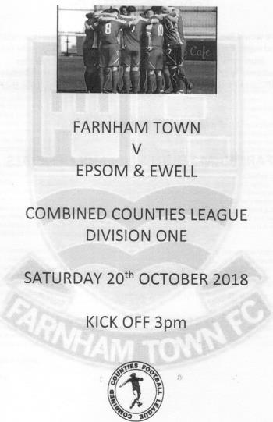
Farnham expose Salts on Funnell debut

Our new Caretaker Manager Simon Funnell could have been excused for wanting an easier start to his tenure than a match against the League leaders, although it could also be argued that by playing one of the top teams we would find out how close we are to them. After this result, he will know that there remains plenty of work to be done as we failed to cause them enough problems, while continuing to concede at an alarming rate.

We took the field with a fairly strong looking side, with the only uninjured absentee of the regulars being the suspended Liam Roberts. Olly Martinez started on the left wing but he was already carrying a slight injury which would eventually cause him to be replaced on the half hour, which was a pity as he was having much success down that flank to that point.

In fact we had a fairly decent first thirty minutes once we had weathered a bit of a storm in the opening few minutes when a couple of desperate clearances were required. In response Reisse Griffin made a good run but got the shot all wrong from twenty yards and on the ten minute mark an Adam Heagney free kick caused a bit of panic but no one was there to take advantage.

In the 17th minute Conor young made a superb reflex save as Kay Conteh found space at the far post but saw his powerful header pushed onto the bar from close range with the ball then being hacked clear before another shot went across our goal a couple of minutes later. Soon after Martinez was replaced by the returning Luke Elgar but this left us with two right footed players on the left and we were never really able to threaten as much from the wings as a result.

However, we then had a great chance to take the lead when Rob Hendry chased Conteh who slipped, leaving our striker through on goal from 35 yards. However, his first touch was a poor one and a grateful Stuart Norman was out quickly to gather the ball for the home side. The missed opportunity would prove costly as we went behind four minutes later in the 41st minute when we lost the ball in the midfield and Lloyd Connelly found himself having to clear a high ball with two strikers bearing down on him. His clearance didn't go far enough and the ball was fed back in where Nick Medcraft buried the chance low to Young's right from ten yards.

This was harsh on our boys and it nearly became two-nil in injury time as a corner was wrongly awarded and the delivery was met at the near post with Elliott Thompson doing well to hook the ball over his own bar to clear the danger.

Despite being behind at the half it was by no means impossible to salvage the position, but the next ten minutes would prove to be our worst period of the match and by the time that was over, so was the match. The home side found the roof of the net with a lob, before Young denied Medcraft who had broken through one on one. A further shot was deflected across our goal for a corner before Steve Betancourt conceded a foul and a yellow card. The delivery into the box was not headed far enough away and Ryan Esprit took full advantage to drill the loose ball at full stretch past Young from twelve yards in the 51st minute. Five minutes later it was 3-0. Betancourt tried to play the ball out of defence but was tugged back. Unfortunately the foul wasn't given and Jayden Englefield avoided the last ditch tackle from Scott Murphy and slotted the ball under the advancing Young.

Clearly it wasn't going to be our day and this was highlighted moments later when Thompson made a fine run into the box. The ball got away from him but Hendry was there to strike at goal, only to see the ball rebound off a defender straight into the arms of Norman!

Griffin made a fine saving challenge for a corner as Farnham threatened to score a fourth goal, but we got on the scoresheet in the 67th minute when a clever pass from Scott Elgar cut out the defence and found Hendry who kept calm and converted under the advancing Norman. Theo Campbell came on for Thompson and nearly scored following a mazy dribble, but his shot was half blocked by a defensive challenge and the ball dribbled through to the keeper. Insult was added to injury when the home side then went straight up the other end and scored far too easily with Medcraft producing a clinical finish in the 72nd minute.

We pressed for a while as we attempted to reduce the arrears and some clever interplay between Heagney and his teammates enabled him to break through into the penalty area and his low ball in from the right was converted at the far post by substitute Luke Elgar, only to see the offside flag raised against him. Then Bobby Bennett received a deep ball from Campbell at the far post but a superb defensive challenge diverted his shot inches wide of the post.

Ultimately, the 4-1 final scoreline was a little harsh on our players, although it is clear we will need to improve, particularly defensively, if we are to challenge for the top spot. However, the squad is clearly behind our new Manager and better results are surely not too far away as we strengthen the squad with some new additions.

Epsom and Ewell: Conor Young, Adam Heagney, Reisse Griffin, Scott Elgar,
Steve Betancourt, Lloyd Connelly, Bobby Bennett, Scott Murphy (c), Rob Hendry, Elliott Thompson, Olly Martinez

Subs: Luke Elgar for Martinez (27), Theo Campbell for Thompson (67),
Kieran Wright for Betancourt (81)

From behind the goal
Epsom & Ewell 5-0 Knaphill Under 23s
Surrey Premier Cup - First Round - Tuesday 23rd October 2018

Perfect evening as Salts end losing run with five star display

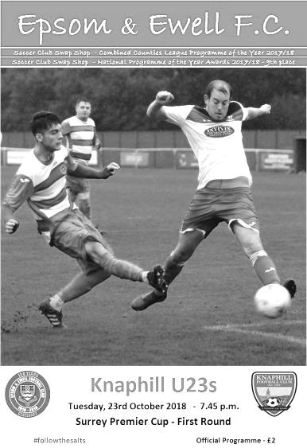
Oh ye of little faith! Just 24 people were there to witness an entertaining display with five goals, a clean sheet and no bookings as we opened up our first ever Surrey Premier Cup campaign with a comfortable victory over the Knaphill Under 23 team at High Road.

We made two changes from our loss at Farnham Town with Luke Elgar coming in at right back at the expense of his brother Scott, while up front Liam Roberts returned from suspension in place of the injured Olly Martinez, making his 50th appearance in the process.

The opening exchanges were fairly even as both teams made attempts to break through although Rob Hendry put Roberts through as early as the sixth minute but his shot was blocked for a corner with the subsequent delivery met by a glancing Scott Murphy header that went beyond the far post. Bobby Bennett was next to try his luck after a deep Roberts delivery had been sent back into the box by Murphy but his shot on the turn from 12 yards was just wide of Jake Taylor's left hand post.

Taylor was to be a busy chap, particularly in the first half and he saved well from Roberts who was causing a lot of trouble for the opponents but the next attack after 17 minutes came from the right where Luke Elgar picked out Hendry with a deep delivery, although the header was straight at the grateful Taylor from six yards out.

The visitors were not without threat though, and three chances in as many minutes around the twenty minute mark came the way of Nathan Thomas, although he snatched at two which went across our goal and the other provided Conor Young with his first regulation save of the evening. At the other end we were getting closer though and a Hendry nutmeg and blocked cross earned us a corner. Although the set piece was cleared, it only went as far as Elliott Thompson whose delivery from the left was just inches ahead of a diving Hendry.

It was just a matter of time though and on the half hour Roberts ran straight at

goal, being brought down by Harry Reed in the area. Bennett's 31st minute penalty was scored, but Taylor was unfortunate after guessing the right way and getting two hands to the ball. It was just too powerful for him. Eight minutes later we doubled our lead after Hendry's defence splitting pass put Bennett through and as he cut inside Taylor he was brought down. This time Bennett gave him no chance with the penalty; his sixth of the season already.

Roberts was also giving the defenders kittens and even had time to deliver a "rabona" cross from the left which was cleared off the line by a defender and on the counter attack Young was down to save smartly for the corner. However, it came to nothing and Bennett returned the favour with a smart pass inside the Knaphill defence to Hendry who held off his defender before steering the ball past Taylor in the 44th minute.

The first half had been an entertaining one and the match was finished off as a contest after just four minutes of the second period after Reisse Griffin played an inch perfect weighted pass around the full back with the outside of his foot and Hendry ran onto it before finishing clinically across Taylor from twelve yards into the far corner.

A number of other chances were created with a Luke Elgar low cross well cut out by Taylor inches ahead of the incoming Roberts, but we extended our lead to five in the 69th minute when Theo Campbell, who had been on the pitch for just seven minutes, finished off the best move of the match with Thompson again setting things up, finding Hendry on the left wing whose low cross provided Campbell with a tap in from inside the six yard box for his first goal for the club.

Taylor was still busy, saving well from Hendry and a defender blocked Murphy's effort from just inside the box as we threatened to score again, but the intensity had gone by this point with the result no longer in doubt and we almost conceded in the final minutes as Young had to firstly claw away a thirty yard lob before being out smartly to save low down from Chad Goulter who limped away from the challenge.

The whistle blew shortly afterwards to signify the end of a good night's work and it was a relief to end our three game losing streak. How good this performance was will only truly be known when we meet another league opponent in Chessington & Hook United on Saturday, but for now you can only beat the team in front of you, which we did fairly conclusively in the end.

Epsom and Ewell: Conor Young, Luke Elgar, Reisse Griffin, Adam Heagney,
Steve Betancourt, Lloyd Connelly, Bobby Bennett, Scott Murphy (c), Rob Hendry,
Elliott Thompson, Liam Roberts

Subs: Theo Campbell for Bennett (62), Scott Elgar for Luke Elgar (70),
Sam Morgan for Murphy (80)

From behind the goal
Chessington & Hook United 1-4 Epsom & Ewell
Combined Counties League - Division One - Saturday 27th October 2018

Record-breaking fightback earns three points at Chalky Lane

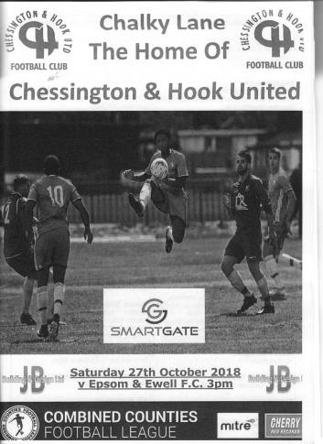
In complete contrast to our awful home record against Chessington & Hook United, the away matches at Chalky Lane have often been memorable ones; from a 6-0 win there in 1974 and a 6-1 win on our most recent visit in 2016, while no-one who was there could ever forget the incredible 5-5 draw back in December of 2011. This match will also go deservedly into that category after a stunning fightback from our players despite being reduced to ten men, then going behind, only to score four times and end up as comfortable winners.

In terms of club achievements I have not been able to trace a match where we scored three times with ten men, let alone four and it was thoroughly deserved against a team that looked ragged and probably somewhat embarrassed by the end. It is of course worth noting that we also had a man sent off in the earlier match between the sides at Chipstead, where we finished that match strongly too and nearly pinched a draw from being 2-0 down. This result provides more than ample revenge for that earlier defeat and leaves Kieron Campbell as the only player to have been on the losing side in both encounters.

I refer to our former player Campbell as he was involved in one of the key incidents of the match; the sending off of our Captain Scott Murphy, from which I picked up many different opinions from people around the sidelines. Of course, the ramifications of that decision will be far-reaching as he will now have three matches on the sidelines to think about his actions, which will also end his ever-present record this season. However, whether fuelled by injustice at the sending off, the substantial celebrations from the home side when they went a goal up, or even as a result of discussions in the dressing room at half time, the ten men can look back at the second half with immense pride in the way they competed against the odds and made the opposition look very average by the end of the match.

In terms of personnel Sam Morgan came in for his first start of the season at right back in place of Luke Elgar, while David Jones came in for Reisse Griffin. Otherwise, the only other change from Tuesday's victory over Knaphill Under 23s came when Theo Campbell started in place of Elliott Thompson who was a late arrival.

The early exchanges were even. A free kick was punched away by Reece Ellis in the Chessington goal just ahead of Murphy, while at the other end Campbell turned Steve Betancourt who pulled him back, rightly earning a yellow card. A Ben Thorne header just cleared our crossbar from a near post free kick but we were beginning to threaten a bit more ourselves until the 24th minute. Campbell tackled Lloyd Connelly but ended up on the floor. Seconds later there was a shout and the referee had waved his red card in the face of Murphy. It appeared to be something out of nothing between Murphy and Campbell who are friends off the pitch, but Campbell was still down and whether he had made more of it than he should, the referee, who was well-positioned, was convinced and we were down to ten men.

We have only had two men sent off this season in nineteen matches, but both have come early in matches against Chessington & Hook, following the early departure of Ricky Borrett back in August. The subsequent free kick just cleared our crossbar, but they were in the ascendency for a while and in the 34th minute a ball through our defence left Jake Heard clear on goal and he finished clinically under Conor Young to give the home side the lead.

We were right up against it now. Chessington were holding the balance of possession and a second goal would surely be terminal, but out of nowhere in the 44th minute a long ball over their defence went straight to Bobby Bennett and he ran in on goal from an angle, striking the ball across Ellis into the far corner from about twelve yards to level the scores.

We didn't realise it at the time but this goal would change the match as it put us back in the match as the teams went off for the interval. Although Darryl Siaw should have hit the target early in the second half we dragged ourselves back into the match, despite going uphill and started to threaten more. Liam Roberts started to cause trouble down the left, while Bennett became more prominent on the right and he did well to close down and half block a clearance from Ellis. The ball ran loose and as Rob Hendry and a defender challenged, it fell back into the path of Bennett. From twelve yards out he probably should have scored, but Ellis made a good save and although Hendry netted the follow-up, he was flagged offside in the process.

On the hour Thompson came onto the field and we started to properly take control of the match. Roberts received a deep crossfield ball before cutting in and letting fly from twenty yards but unfortunately the shot went straight at Ellis. In the 66th minute though, Louis Chin went straight through Roberts from behind and picked up a yellow card. From the free kick a minute later we took the lead as Connelly met a deep Adam Heagney delivery with a thumping header from just six yards out which gave Ellis no chance at all.

Nine minutes later we extended our lead in unusual circumstances when Ellis attempted to clear a back pass but Hendry jumped to block the clearance and the ball rebounded off his back, beyond Ellis and rolling into the vacant net from the edge of the penalty area. It was a bizarre goal, but we had been pressing for a third goal and I think the home side knew the game was up at that point.

We continued to push and Bennett robbed Thorne on the touchline and ran in on Ellis, cutting back before attempting to find the far corner, but he was denied by the keeper's outstretched foot. Then Hendry then clipped the bar from fifteen yards after great work from Bennett and substitute Germaine Jeannoel. However, Bennett would not be denied and in the 98th minute of the match Hendry's crossfield ball was reached by our winger just ahead of Ellis and he had the easy task of rolling the ball into the net with virtually the last kick of the contest.

Looking back after the match it is clear that this was a quite incredible comeback from our boys. It's not particularly rare to concede first and go on to win, although to do it with ten men appears to be unprecedented in our history and credit is due to all of them because make no mistake, a fourth league defeat in a row would have left us well adrift in the promotion stakes. Hopefully we can now take this momentum building result into our next encounter with Frimley Green, where hopefully we will manage to keep all of our players on the pitch for ninety minutes!

Epsom and Ewell: Conor Young, Sam Morgan, David Jones, Adam Heagney,
Steve Betancourt, Lloyd Connelly, Bobby Bennett, Scott Murphy (c), Rob Hendry, Theo Campbell, Liam Roberts

Subs: Elliott Thompson for Campbell (61), Joshua Caulcrick for Morgan (75),
Germaine Jeannoel for Roberts (94)

How we stand – Locally and Nationally – inc Sat 27/10/18
Here is the latest update on where we all stand. To summarise for new readers, there are 28 promotion places currently available at Step Six, with 358 teams battling away for those spots. The Champions of each League are guaranteed a promotion, with the best nine runners-up also going up. This number looks as though it will rise by three due to no likely promotions from the South West Peninsula League and the expected but not yet confirmed folding of Isthmian League Thamesmead Town, but this could all change still. For now we’ll continue to look at the 28 and anything else will be a bonus!

In our previous issue, we were listed as 37th Nationally but since then we lost against Sheerwater, British Airways and Farnham Town, and now sit in 93rd place despite our win over Chessington & Hook United.

Below is our current League table sorted by points per game, while across the page we have the overall top ten and the 28 clubs who would go up if the season ended right now.

Farnham Town, currently holding the runners-up spot in our League on points per game, have the 15th best record of the 19 second placed teams. Our league is so competitive right now that it may well prove to be just the Champions that go up, but I’ll keep updating the position here while we remain involved.

Combined Counties League Division One Table – by PPG
 | Pld | W | D | L | Pts | GD | PPG | Pos
Bedfont & Feltham | 11 | 8 | 3 | 0 | 27 | 32 | 2.45 | 4
Farnham Town | 14 | 9 | 3 | 2 | 30 | 20 | 2.14 | 1
Sheerwater | 14 | 9 | 3 | 2 | 30 | 15 | 2.14 | 2
AC London | 14 | 9 | 2 | 3 | 29 | 12 | 2.07 | 3
Frimley Green | 13 | 7 | 5 | 1 | 26 | 8 | 2.00 | 5
Epsom & Ewell | 13 | 8 | 0 | 5 | 24 | 13 | 1.85 | 7
Dorking Wanderers Res | 14 | 7 | 4 | 3 | 25 | 8 | 1.79 | 6
Sandhurst Town | 12 | 6 | 3 | 3 | 21 | -2 | 1.75 | 10
Ash United | 13 | 6 | 4 | 3 | 22 | 9 | 1.69 | 8
British Airways | 15 | 6 | 3 | 6 | 21 | -1 | 1.40 | 9
Chessington & Hook United | 14 | 6 | 1 | 7 | 19 | -4 | 1.36 | 11
Tooting Bec | 13 | 5 | 2 | 6 | 17 | 2 | 1.31 | 12
Godalming Town | 12 | 3 | 2 | 7 | 11 | -10 | 0.92 | 13
Kensington Borough | 13 | 3 | 2 | 8 | 11 | -11 | 0.85 | 14
Eversley & California | 11 | 3 | 0 | 8 | 9 | -9 | 0.82 | 15
Fleet Spurs | 12 | 3 | 0 | 9 | 9 | -12 | 0.75 | 16
Bagshot | 14 | 2 | 2 | 10 | 8 | -40 | 0.57 | 17
FC Deportivo Galicia | 12 | 1 | 2 | 9 | 5 | -11 | 0.42 | 18
Cove | 12 | 1 | 1 | 10 | 4 | -19 | 0.33 | 19

Step Six Table – by PPG – Top 10
 | Which League? | Pld | Pts | GD | PPG | League Pos.
Cheltenham Saracens | HellW | 6 | 18 | 19 | 3.00 | 1
Tavistock | SWP | 11 | 31 | 31 | 2.82 | 4
Broadfields United | SSML | 10 | 28 | 20 | 2.80 | 2
Selston | E.Mids | 14 | 38 | 31 | 2.71 | 1
Tividale | W.Mids | 16 | 43 | 52 | 2.69 | 1
Welling Town | SCEFL | 12 | 32 | 22 | 2.67 | 1
Harleston Town | EastN | 14 | 37 | 31 | 2.64 | 1
Harefield United | SSML | 11 | 29 | 26 | 2.64 | 1
Sherwood Colliery | E.Mids | 13 | 34 | 32 | 2.62 | 2
AFC Stoneham | Wess | 10 | 26 | 36 | 2.60 | 3
Epsom & Ewell | We are 93rd | 13 | 24 | +13 | 1.85 | 3

Step Six Table – The 28 Promoted Clubs if the season ended today
The 19 Champions – Based on current PPG
 | Which League? | Pld | Pts | GD | PPG | League Pos.
Cheltenham Saracens | HellW | 6 | 18 | 19 | 3.00 | 1
Tavistock | SWP | 11 | 31 | 31 | 2.82 | 4
Broadfields United | SSML | 10 | 28 | 20 | 2.80 | 2
Selston | E.Mids | 14 | 38 | 31 | 2.71 | 1
Tividale | W.Mids | 16 | 43 | 52 | 2.69 | 1
Welling Town | SCEFL | 12 | 32 | 22 | 2.67 | 1
Harleston Town | EastN | 14 | 37 | 31 | 2.64 | 1
AFC Stoneham | Wess | 10 | 26 | 36 | 2.60 | 3
Thame Rangers | HellE | 5 | 13 | 10 | 2.60 | 3
AFC Varndeanians | Scomb | 12 | 31 | 23 | 2.58 | 1
Carlisle City | NWCN | 14 | 36 | 17 | 2.57 | 2
Racing Club Warwick | Midland | 11 | 28 | 32 | 2.55 | 2
Anstey Nomads | UCL | 11 | 28 | 32 | 2.55 | 1
Bedfont & Feltham | CCL | 11 | 27 | 32 | 2.46 | 4
May & Baker Eastbrook | EastS | 9 | 22 | 18 | 2.44 | 4
Winterton Rangers | NCEL | 14 | 34 | 25 | 2.43 | 1
Billingham Town | Northern | 13 | 31 | 26 | 2.39 | 1
Cheddar | Western | 11 | 26 | 28 | 2.36 | 1
Rylands | NWCS | 13 | 30 | 32 | 2.31 | 1
The 9 Best Runners-Up
Harefield United | SSML | 11 | 29 | 26 | 2.64 | 1
Sherwood Colliery | E.Mids | 13 | 34 | 32 | 2.62 | 2
Black Country Rangers | W.Mids | 13 | 33 | 30 | 2.54 | 2
Longridge Town | NWCN | 15 | 38 | 46 | 2.53 | 1
Lutterworth Town | UCL | 10 | 25 | 25 | 2.50 | 2
Sutton Athletic | SCEFL | 10 | 25 | 14 | 2.50 | 3
Thornbury Town | HellW | 6 | 15 | 18 | 2.50 | 3
Steyning Town | Scomb | 11 | 27 | 18 | 2.46 | 3
Halstead Town | EastS | 14 | 34 | 16 | 2.43 | 1

This Day in History - 3rd November
Date | Day | Competition |  | Opponents |  | Scorers
03/11/28 | Sat | London League | H | Grays Athletic | 3-2 | R.Marlow (2), J.Parr
03/11/34 | Sat | Amateur Cup 3q | A | Wills Sports | 4-3+ | E.Hannam, M.Wiggins, T.Dunne, J.Jones
03/11/45 | Sat | London League | A | Edgware | 1-6 | G.Brogdale
03/11/51 | Sat | Corinthian League | H | Grays Athletic | 3-3 | T.Wright (2), R.Orford
03/11/56 | Sat | Corinthian League | H | Chesham United | 8-2 | B.Jenkins (4), D.Hermitage, J.Bangs (2), T.Day
03/11/62 | Sat | Corinthian League | H | Worthing | 1-2 | T.Monk
03/11/73 | Sat | Surrey Senior League | H | Whyteleafe | 5-1 | T.Tuite (3), D.Ritman (2)
03/11/79 | Sat | Isthmian League 1 | H | Hertford Town | 5-3 | J.Hunn (3), T.Tuite (2)
03/11/81 | Tue | Isthmian League 1 | H | Kingstonian | 1-2 | P.Gaydon
03/11/84 | Sat | Isthmian League Premier Division | H | Hitchin Town | 3-0 | S.Hill (3)
03/11/90 | Sat | F.A. Vase 1 | H | Shoreham | 2-3 | S.Barwick, A.Boxall
03/11/93 | Wed | Isthmian League 3 | A | Harlow Town | 0-2
03/11/01 | Sat | Isthmian League 3 | H | Chalfont St Peter | 5-1 | S.Hatton (2), J.Rogers, J.Hall, M.Owen
03/11/07 | Sat | Combined Counties Premier Division | H | Bedfont Green | 1-2 | R.Burns
03/11/09 | Tue | Combined Counties Premier Division | H | Bedfont | 2A1 | M.Jarman, C.West
Abandoned after 88 minutes for a partial floodlight failure
Historical Decades
90 years ago – Epsom Town F.C.
03/11/28 | Sat | London League | H | Grays Athletic | 3-2 | R.Marlow (2), J.Parr
80 years ago – Epsom F.C.
05/11/38 | Sat | London Senior Cup 2 | A | Wood Green Town | 0-1
70 years ago – Epsom F.C.
06/11/48 | Sat | London League | H | Dartford Reserves | 4-3 | B.Cutter (2), F.Chitty, T.Goodall
60 years ago – Epsom F.C.
08/11/58 | Sat | Corinthian League | H | Maidenhead United | 2-1 | T.Millard, M.Carlson
50 years ago – Epsom & Ewell F.C.
02/11/68 | Sat | Amateur Cup 3q | A | Tooting & Mitcham United | 0-5
40 years ago – Epsom & Ewell F.C.
04/11/78 | Sat | Isthmian League 1 | H | St Albans City | 4-0 | P.Weller, T.Tuite, J.Hunn, G.Archer
30 years ago – Epsom & Ewell F.C.
05/11/88 | Sat | F.A. Vase 1 | A | Banstead Athletic | 2-1+ | B.Perkins, R.Strong
20 years ago – Epsom & Ewell F.C.
07/11/98 | Sat | F.A. Vase 1 | H | Stansted | 1-1+ | J.Tome
10 years ago – Epsom & Ewell F.C.
01/11/08 | Sat | Combined Counties Premier Division | A | North Greenford United | 1-4 | R.Burns

History Corner – 3rd November
90 years ago today we were at home to Grays Athletic in a London League match, winning 3-2. Reg Marlow scored twice while the ill-fated Jack Parr scored the other goal. Our last meeting in the May of 1928 had resulted in a narrow Epsom 2-1 win which gave us the London League title. This time we’d have to settle for fifth place but it must be noted that Grays Athletic would become runners-up for the second year in a row, but had they taken a point here they would have been Champions, cruelly losing out to Mitcham Wanderers on goal average at the end of the season.

84 years ago today we squeezed past new Surrey Senior League team Wills Sports over at Hill Farm in Carshalton by four goals to three after extra time. In fact we required a 90th minute equaliser from Jimmy Jones to take the tie into the extra period in the first place, with Tommy Dunne scoring a 119th minute winner. We would defeat Redhill in the next round before bowing out 2-0 at eventual finalists Wimbledon in what would prove to be our final appearance in the First Round Proper of the Amateur Cup.

80 years ago this week we were beaten 1-0 by Wood Green Town in the London Senior Cup. Wood Green would remain into the seventies before merging with Tufnell Park Edmonton and changing their name to the more familiar Haringey Borough.

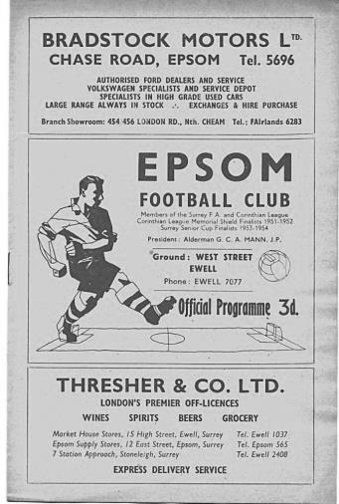
62 years ago today we were at home to Chesham United in a Corinthian League match where Jim Morris, father of future Epsom Captain Graham, was performing his usual heroics in goal. We trailed by two goals at the half, only for Morris to be injured and we took full advantage, scoring eight goals without reply to win 8-2! (see programme pictured) This was the most goals we had ever scored in the second half until our famous 9-2 win at Bedfont & Feltham in 2016, when of course all nine Epsom goals came in the second half.

45 years ago today we defeated Whyteleafe 5-1 in a Surrey Senior League match at West Street with Tommy Tuite scoring three of the goals. Dave Ritman got the other two. Then six years after that and 39 years ago today we scored five at home again, although this time Tuite only scored two goals, while Jeff Hunn got the hat trick in a 5-3 Isthmian League win over Hertford Town. In goal that day for the visitors was a little known Mark Halsey, who would of course go on to greater achievements as a referee!

34 years ago today we were experiencing tough times in our first season in the Premier Division of the Isthmian League. We had been narrowly defeated on a number of occasions, but it was clear that there was quality in the team and this day we finally secured our first league win of the season when we smashed Hitchin Town 3-0 with a first half hat trick from Steve Hill. It could have been more and Colin Miles skied a penalty in the second half, but we were up and running and would destroy Leytonstone & Ilford 5-1 on their own patch just three days later with Hill again scoring three goals. Only once since then has a player scored hat tricks in consecutive matches.

30 years ago this week we looked to be heading out of the F.A. Vase at Merland Rise as we trailed 1-0 with time running out, only for Brian Perkins to score an equaliser from close range and Richard Strong popped up with the winner in extra time as we defeated Banstead Athletic 2-1. A Second Round tie with Three Bridges awaited us in the next round.

9 years ago today goals from Mark Jarman and Charlie West appeared to be enough for a 2-1 home win at Merland Rise over Bedfont, only for one of the floodlight pylons to fail with just two minutes remaining and the referee abandoned the match. Fortunately when the match was replayed, we would also win it 2-1 with an 88th minute goal. Karma!

Centre page for results

Centre page for results

Frimley Green F.C. – History
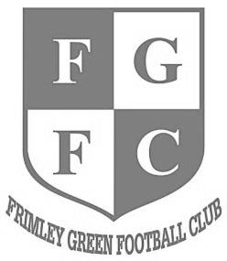
The club was founded in 1919 and currently play at Frimley Green Recreation Ground.

The present clubhouse was erected in 1972 when ‘The Green’ played in the London Spartan League and used a pitch on the lower part of the park with the changing rooms where the car park now is. A few years later a new pitch was laid adjacent to the clubhouse and changing rooms were added.

The Reserve Team joined the Combined Counties League in 1979 and at the start of the 1981/82 season the First Team switched across and Floodlights were installed for the first time. The Club competed in the League for a period of 15 years, during which time they won the Dan Air Elite Cup and the Reserves won the Division One Challenge Cup.

Due to the financial situation in 1994 the club voluntarily dropped down into junior football into the Surrey Intermediate League (Western).The next four seasons saw a period of rebuilding and repaying debts and the club were finally accepted into the Surrey Premier League in 1999, after finishing Runners-up and winning the League Cup. Off the field new Floodlights were installed and a Boardroom created.

A three year spell followed in the renamed Surrey Senior League, which saw the club finish fourth, sixth and Runners–up and attain promotion back into the Combined Counties League where they have played since. Season 2004/05 was the most successful to date, in the Combined Counties League, with the club finishing in 15th Place and amassing 58 points.

Season 2005-06 was very disappointing on the playing front but we managed to avoid finishing in a relegation position, however, despite substantial ground improvements we were demoted on ‘ground grading’, to make way for seven clubs from the old Ryman Division Two (including Epsom & Ewell!).

In the next four seasons in Division One we had mixed fortunes, finishing 6th at the end of season 2007/08 but then in season 2008/09 we finished 3rd from bottom but had our most successful season ever in the FA Vase, reaching the third round and won an FA Cup match for the first time.

In season 2009/10 we managed to finish high enough up the table to retain our FA Cup place but 2010/11 was a poor season. 2011/12 saw the appointment of Paul Miles and Ian Maynard mid-season and in 2012/13 we won the Division One title and won three FA Vase games along the way.

In 2013/14 Paul and Ian left us and Derren Martin. 2014/15 was a turbulent season which saw Derren Martin replaced by Paul Miles who in turn was replaced by Phil Ruggles & Andy Clement but they were unable to stop the slide in fortunes which led to relegation. 2015/16 saw another mid-table finish. At the start of 2016/17 there were further management changes with John Cook and Jamie Daltry coming in for 2017/18. Roland Baker joined the team and we narrowly missed out on promotion but did get our FA Cup place back.

Previous Managers
In our latest instalment we cover the transition from the departure of Doug Whitehead in 1956 and the two men that followed him.

Bill Fraser – Manager 1956 and Fred Chitty – 1956-59

The halcyon days of 1956 were good ones for sport. Jim Laker took 19 wickets in a Test Match at Old Trafford as England won the Ashes, whilst we would all have been looking forward to the first ever Olympics in the Southern Hemisphere which Melbourne would host in October. For our part, we were looking for another Manager, following the departure of Doug Whitehead. However, he had left the club in a good position and we were able to attract Bill Fraser to the hot seat.

Bill had taken a year out since being Manager at Kingstonian, but his real achievements had happened a few years earlier when with Walton & Hersham they had won three consecutive Corinthian League titles, in addition to a pair of Amateur Cup Semi-Finals. He had been a professional with Fulham and Northampton Town before the war before starting his Managerial career at Salisbury and was quite a big name in these circles of football.

Unfortunately for Fraser, results were middling and although we had progress in the Amateur Cup he resigned on 27th October 1956 saying that he was having trouble making night shifts. Regrettably this was a cover story as Fraser’s health was very poor and whether his earlier time out was connected to the illness or not, he passed away in the December of that same year.

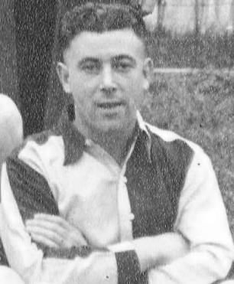
The club of course had to make another appointment and this time they went for the Assistant Manager Fred Chitty. Born on 22nd April 1918 Fred (pictured below in the late 1940s) was a popular choice being a local lad and had been a former player on the left wing, still aged just 37 and he had even sold programmes outside the ground as a youngster in the late twenties. By now he had moved from West Street to Middle Lane, where he would remain until his death in 1993 and worked in a Mitcham Dry Cleaners, being described as a “dapper little man”.

He had briefly been a Schoolboy International, making his debut for the club in November 1936 and during the war had guested for Crystal Palace, Norwich City and Falkirk and was the only Amateur in the 8th Army team that contained no less a player than Tom Finney. He returned to play for Epsom after the war and had Managed the Youth Team and then the ‘A’ Team with a young Johnny Byrne in the ranks, before getting the job of Reserve Manager. He knew the players well and was a sensible choice.

Despite the slow start, the 1956/57 season would in fact prove to be one of our best, even if ultimately we would fall short of a League and Cup double that looked a real possibility up until the final week. Part of the reason for the success was a signing from Redhill, Johnny Bangs, who made his debut in September, scoring a debut at Maidstone United and registering an incredible 23 goals in his opening ten matches for the club, a record that unsurprisingly stands to this day. We were a free scoring side during Chitty’s first season in charge with Dave Hermitage and Brian Jenkins each finding the net on 22 occasions and scoring five times against two Isthmian League giants Kingstonian and Dulwich Hamlet in County Cup ties before being fluked out of a Semi-Final by Wimbledon by a cross that dropped in at the far post.

In the League, a 2-1 win at Edgware put us top of the table on 24th April 1957, aided by the 53rd goal of the season for Bangs, but three days later we lost the Corinthian League Memorial Shield Final 2-0 to Maidenhead United and then promptly lost our three remaining League fixtures in the final week of the season with Bangs failing to score in any as we tailed off to finish in fourth place.

We had been unfortunate to depart the Amateur Cup too, denied an equaliser in a fourth qualifying round replay against Sheppey United when the referee blew for full time over two minutes early and in 1957/58 we would also suffer heartache at the final qualifying round stage, losing 3-2 to Eastbourne, who had also been responsible for two of those late season defeats to deny us the title the previous season.

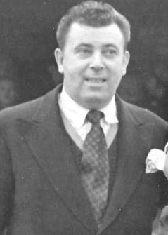
Faced with the disappointment of the Amateur Cup defeat, Chitty introduced a sensible “no train, no play” policy. This worked out well for a while and we defeated Sutton United 2-0 at West Street in the Surrey Senior Cup in December of that year, although eventual Amateur Cup winners Woking then defeated us 4-2 at home in the Quarter-Final. League results were average and contributed to an eighth place finish from 15 teams, but then in February Bangs missed training and was dropped for the match against Uxbridge, at which point he promptly left for Carshalton Athletic. He would return briefly in a couple of seasons, but this would count against our Manager.

Supporters were also beginning to get angry. Despite a reasonable amount of success, they had even tried to organise a “Sack Fred Chitty” movement which fortunately lost momentum after the win over Sutton United. There had previously been a campaign against a talented youngster Bernard Wales who had been groomed through the Youth team and into the firsts by Chitty himself but felt the need to leave. The news that he had just moved from a successful spell at Hounslow to sign professional forms at Brighton & Hove Albion must have been difficult to take.

However, as the new 1958/59 season opened up Fred had to write in the programme asking for support and tolerance, but that day we were defeated 3-1 at home by Uxbridge, for whom Derek Hoddle, father of Glenn, scored a hat trick. This was followed by the departure of Hermitage to Sutton United in September where he would learn much under the tutelage of new Manager Malcolm Allison. Chitty didn’t have a lot of support higher up either, with former luminaries as Bill Carpenter, a former Secretary and crucially brother of Chairman Peter, criticising his handling. Fred responded by saying the remarks were "a small stone in an empty can"!

Unfortunately, his main aim to reach the First Round of the Amateur Cup ended badly with a 3-4 home defeat to little Surrey Senior League Addlestone and this was further ammunition for the doubters, some of whom openly questioned his ability and gave all the credit to Doug Whitehead.

This was harsh. As a local lad, his dedication to the cause was never in doubt. An example of this came following the Addlestone defeat when he was made aware that a local striker by the name of Tommy Millard had just been released by Leatherhead, so he went into Epsom looking for him. He found him with his fiancée at the junction of East Street and Hook Road at around midnight and borrowed a pen from a passer-by to get him to sign up, and the faith was justified as he would score in his first five matches for the club. Tommy (who is now 86) and his wife remembered the story well when I met them a few years ago!

However, results were disappointing, maybe understandably so after the departures. We had a new owner, John Martin, who was extremely wealthy and lived in tax exile on the Isle of Man. I have heard many stories of this man’s generosity, yet it was perhaps telling that in late 1958 accounts were revealed that showed almost everyone got paid for doing something except him. Maybe he received some support behind the scenes, but on the 17th January 1959 Chitty resigned and within a couple of weeks Peter Carpenter left too, with the announcement delayed slightly, although it was clear that the two events happened fairly simultaneously. Fred would return briefly in 1962 but for now the Coach, Tommy Rochester, another former player, was promoted into the Manager’s position. More about him in the next issue.

Above and Below
Surrey Elite League Table
incl Saturday 27th October | P | W | D | L | F | A | Pts | GD
Battersea Ironsides | 11 | 7 | 2 | 2 | 28 | 18 | 23 | +10
Westside | 10 | 6 | 2 | 2 | 22 | 14 | 20 | +8
AFC Cubo | 10 | 6 | 2 | 2 | 26 | 20 | 20 | +6
Royal Holloway Old Boys | 11 | 5 | 2 | 4 | 27 | 16 | 17 | +11
Chessington KC | 9 | 5 | 2 | 2 | 24 | 16 | 17 | +8
Spartans Youth | 8 | 5 | 1 | 2 | 15 | 9 | 16 | +6
Merrow | 10 | 5 | 1 | 4 | 22 | 18 | 16 | +4
Staines Lammas | 9 | 4 | 2 | 3 | 22 | 9 | 14 | +13
Horsley | 10 | 4 | 1 | 5 | 25 | 27 | 13 | -2
Farleigh Rovers | 11 | 4 | 1 | 6 | 18 | 25 | 13 | -7
Worcester Park | 10 | 3 | 3 | 4 | 16 | 23 | 12 | -7
NPL | 9 | 3 | 2 | 4 | 21 | 20 | 11 | 1
AFC Spelthorne Sports | 10 | 2 | 3 | 5 | 14 | 26 | 9 | -12
West End Village | 9 | 1 | 1 | 7 | 14 | 30 | 4 | -16
Ripley Village | 11 | 0 | 3 | 8 | 11 | 34 | 3 | -23
Godalming & Farncombe | Resigned after one match
For the first time today we have a little look at the Surrey Elite League. This League is the one directly below us and is one of the feeders to this division. Two teams are scheduled to be relegated from our division with the Surrey Elite and the Middlesex County League being the recipients.

This season we have welcomed British Airways from the Middlesex County, while last year’s Surrey Elite League Champions were Tooting Bec.

As we look at this season’s standings, the first thing I notice is the three relegated clubs from last season, all of which were enforced due to the ground gradings. These are Worcester Park, Farleigh Rovers and Staines Lammas. Much has been made of these clubs being harshly treated by the F.A. but I don’t share that view. In much of the Country, those three clubs would find themselves in a minority of clubs without lights at Step Seven, so why should they be allowed to remain at Step Six when other clubs have spent much money to upgrade their grounds accordingly?

It is of course very unlikely that we will see any of these clubs back in at Step Six in the future without serious upgrades to their grounds, especially as it appears as though we may drop from 19 Step Six Leagues to just 16 for season 2020/21. Many clubs are due to earn promotion next season to fill the new Step Four League and two Step Five Leagues so extra relegations appear unlikely, while I’ll stick my neck out here and say that four or maybe five could be promoted from our division at the end of next season.

Anyway, back to the League itself where it’s tight at the top. My money is on Westside though, a Christian faith club that currently shares with AFC Croydon Athletic, while I’m not sure whether Battersea or AFC Cubo currently have the facilities for Step Six football.

Combined Counties League Premier Division Table
incl Tuesday 30th October | P | W | D | L | F | A | Pts | GD
Chertsey Town | 12 | 10 | 1 | 1 | 29 | 11 | 31 | +18
Banstead Athletic | 14 | 6 | 8 | 0 | 21 | 11 | 26 | +10
Sutton Common Rovers | 12 | 7 | 2 | 3 | 22 | 14 | 23 | +8
Redhill | 13 | 7 | 1 | 5 | 26 | 23 | 22 | +3
Abbey Rangers | 13 | 7 | 1 | 5 | 21 | 25 | 22 | -4
Southall | 13 | 5 | 4 | 4 | 20 | 16 | 19 | +4
Colliers Wood United | 13 | 5 | 4 | 4 | 20 | 24 | 19 | -4
CB Hounslow United | 13 | 5 | 3 | 5 | 24 | 17 | 18 | +7
Camberley Town | 12 | 6 | 0 | 6 | 20 | 19 | 18 | +1
Guildford City | 11 | 5 | 2 | 4 | 17 | 17 | 17 | 0
Spelthorne Sports | 11 | 5 | 1 | 5 | 23 | 16 | 16 | +7
Balham | 11 | 5 | 1 | 5 | 21 | 16 | 16 | +5
Horley Town | 13 | 4 | 4 | 5 | 18 | 23 | 16 | -5
Raynes Park Vale | 13 | 4 | 4 | 5 | 17 | 24 | 16 | -7
Cobham | 12 | 4 | 3 | 5 | 16 | 21 | 15 | -5
Badshot Lea | 13 | 4 | 3 | 6 | 21 | 28 | 15 | -7
Knaphill | 14 | 4 | 1 | 9 | 17 | 26 | 13 | -9
Hanworth Villa | 11 | 2 | 4 | 5 | 11 | 15 | 10 | -4
Walton & Hersham | 13 | 2 | 3 | 8 | 23 | 31 | 9 | -8
AFC Hayes | 13 | 2 | 2 | 9 | 12 | 21 | 8 | -9
Here is the latest state of play in the division above us. I’ll be honest I expected the two clubs to go up would be Sutton Common Rovers and Walton & Hersham and whilst the former are still well involved, the latter have had a very poor start to the season, resulting in the rather sudden sacking of former Worcester Park Manager Gary Taylor.

Taylor had much success last year but with the Swans out of the promotion battle and the League Cup too, the board acted swiftly. Whether they were right or not, time will tell, but he remains out of work currently.

Bearing in mind where they finished last season it is arguably a surprise to see both Chertsey Town and Banstead Athletic up at the top of the table with Athletic still unbeaten in the League after 14 matches; an achievement they surely haven’t bettered since their glory days in the fifties. Chertsey Town’s rise is more explainable with former AFC Wimbledon Manager Dave Anderson coming in at the end of last season and I am assured; a hefty increase in investment there with one of the people who bankrolled the club in the nineties coming back on board. It looks like Chertsey could be headed back in the right direction.

As for our rivals at Gander Green Lane, Daryl Cooper-Smith has departed for Westfield and I am aware that both James Taylor and Matt Ferdinando from our former players are now long term injured with Dan Dean apparently leaving the club also. Craig Hastings, Matt Tanton and Matt Farrell remain however, and they have been joined by some impressive youngsters and the veteran Phil Page. Clearly if and when we get back to Step Five, it is very likely that some serious money may well be required to compete at the top of that table once again.

Player Sponsorship
Here is the latest list for 2018/19, with new photos showing all of our players and Management that are available for sponsorship.

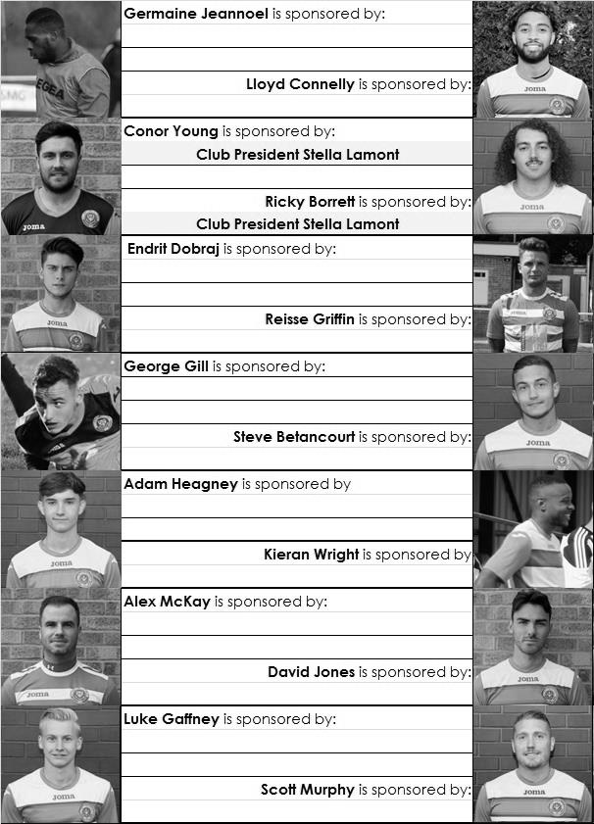

Sponsorship costs just £40 and it is easy to do. Just select a player who has not been previously sponsored and let a Committee Member know that you would like to sponsor them. Beware though. Until we have received the money it is possible for someone to jump in front of you, so don’t delay, sponsor today!

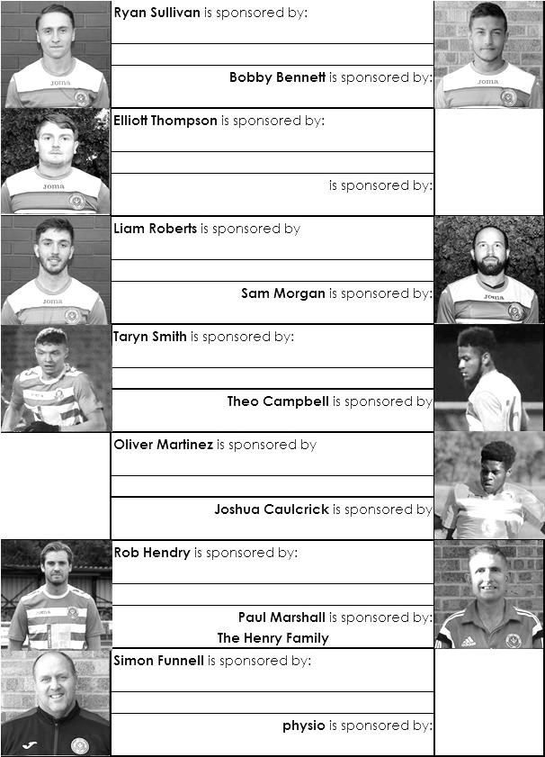

CCL Division One Club Directory
AC LONDON: Telephone: 0208 660 5491 - Colours: Orange/Black/Black
Ground: Whyteleafe FC - 15 Church Road, Whyteleafe. CR3 0AR

ASH UNITED: Telephone: 01252 344264 - Colours: Green with Red Trim/Green/Green
Ground: Shawfields Stadium, Youngs Drive, Shawfields Road, Ash, Aldershot. GU12 6RE

BAGSHOT: Telephone: 01252 623804 - Colours: Yellow/Black/Black
Ground: Fleet Town FC - Calthorpe Park, Crookham Road, Fleet. GU51 5FA

BEDFONT & FELTHAM: Telephone: 0208-890 7264 - Colours: Yellow/Blue/Blue

Ground: The Orchard, Hatton Road, Bedfont. TW14 9QT

BRITISH AIRWAYS: Telephone: 0208-890 7264 - Colours: Sky Blue/Navy Blue/Navy Blue
Ground: Bedfont & Feltham FC - The Orchard, Hatton Road, Bedfont. TW14 9QT

CHESSINGTON & HOOK UNITED: Telephone: 01372-602263 Colours: All Blue
Ground: Chalky Lane, Chessington. KT9 2NF

COVE: Telephone: 01252 543615 Colours: Yellow/Black/Black
Ground: Oak Farm, Squirrel Lane, Cove GU14 8PB

DORKING WANDERERS RES Telephone: 01306 400151 - Colours: Red & White Stripes/ Blue/ Red
Ground: Meadowbank Stadium, Mill Lane, Dorking. RH4 1DX

EPSOM & EWELL Telephone: 01737-553250 - Colours: Royal Blue & White Hoops/Royal Blue/Royal Blue - Ground: Chipstead FC, High Road, Chipstead. CR5 3SF

EVERSLEY & CALIFORNIA Telephone: 0118 973 2400 - Colours: - White & Royal Blue Hoops /Royal Blue/ Royal Blue - Ground: Fox Lane, off Reading Road, Eversley. RG27 0NS

FARNHAM TOWN Telephone: 01252 715305 - Colours: - Claret & Sky Blue /White/ Claret & Blue
Ground: Memorial Ground, Babbs Mead, West Street, Farnham. GU9 7DY

FC DEPORTIVO GALICIA Telephone: 0208 831 9067 - Colours: Royal Blue/Royal Blue/White
Ground: Bedfont Sports FC - Bedfont Sports Club, Hatton Road, Bedfont. TW14 9JR

FLEET SPURS Telephone: 01252 662810 - Colours: Dark Blue with Red Trim/Dark Blue/Dark Blue
Ground: Kennels Lane Farnborough. GU14 0ST

FRIMLEY GREEN Telephone: 01252 835089 - Colours: All Blue
Ground: Frimley Green Recreation Ground, Frimley Green Road, Frimley. GU16 6JY

GODALMING TOWN Telephone: 01483 417520 - Colours: Yellow/Green/Yellow
Ground: Wey Court, Meadrow, Godalming. GU7 3JE

KENSINGTON BOROUGH Telephone: 01372 360151 - Colours: All Blue
Ground: Leatherhead FC – Fetcham Grove, Guildford Road, Leatherhead. KT22 9AS

SANDHURST TOWN Telephone: 01252 878768 - Colours: Red & Black Stripes/Black/Black
Ground: Bottom Meadow, Sandhurst Memorial Park, Yorktown Road, Sandhurst. GU47 9BJ

SHEERWATER Telephone: 01483 772470 - Colours: Royal Blue & White/Royal Blue/Royal Blue
Ground: Woking FC - Laithwaite Community Stadium, Kingfield, Kingfield Road, Woking. GU22 9AA

TOOTING BEC Telephone: 0208 540 8843 - Colours: Black & White Stripes/White/White & Black
Ground: Raynes Park Vale FC – Prince George’s Playing Fields, Grand Drive, Raynes Park. SW20 9DZ

Combined Counties League Premier Division
Opponents All-time Records
inc Tuesday  30th October | P | W | D | L | F | A | PPG | GD | Best  Win | Worst  Loss
Bedfont & Feltham | 2 | 2 | 0 | 0 | 13 | 3 | 3.00 | +10 | 9-2 | -
AC London | 1 | 1 | 0 | 0 | 6 | 0 | 3.00 | +6 | 6-0 | -
Bagshot | 2 | 2 | 0 | 0 | 4 | 0 | 3.00 | +4 | 3-0 | -
FC Deportivo Galicia | 1 | 1 | 0 | 0 | 3 | 0 | 3.00 | +3 | 3-0 | -
Tooting Bec | 1 | 1 | 0 | 0 | 3 | 1 | 3.00 | +2 | 3-1 | -
Fleet Spurs | 1 | 1 | 0 | 0 | 3 | 2 | 3.00 | +1 | 3-2 | -
Frimley Green | 10 | 8 | 1 | 1 | 32 | 5 | 2.50 | +27 | 7-1 | 0-1
Godalming Town | 3 | 2 | 0 | 1 | 4 | 5 | 2.00 | -1 | 2-1 | 0-3
Ash United | 19 | 10 | 3 | 6 | 48 | 31 | 1.74 | +17 | 6-0 | 0-3
Farnham Town | 18 | 9 | 4 | 5 | 31 | 29 | 1.72 | +2 | 3-0 | 1-4
Cove | 35 | 16 | 9 | 10 | 78 | 57 | 1.63 | +21 | 7-0 | 1-6
Chessington & Hook United | 30 | 13 | 9 | 8 | 63 | 45 | 1.60 | +18 | 6-0 | 1-3
Sheerwater | 5 | 2 | 2 | 1 | 10 | 5 | 1.60 | +5 | 3-0 | 2-3
Sandhurst Town | 15 | 6 | 0 | 9 | 27 | 28 | 1.20 | -1 | 4-0 | 1-3
British Airways | 1 | 0 | 0 | 1 | 2 | 3 | 0.00 | -1 | - | 2-3
Dorking Wanderers Res | 1 | 0 | 0 | 1 | 3 | 5 | 0.00 | 0 | - | 3-5
Eversley & California | 0 | 0 | 0 | 0 | 0 | 0 | 0.00 | 0 | - | -
Kensington Borough | 0 | 0 | 0 | 0 | 0 | 0 | 0.00 | 0 | - | -

Match and Ball Sponsorships – 2018/19
Opponent | Date | Match Sponsor | Ball Sponsor
Chessington & Hook Utd | 21/08/18 | Club President - Stella Lamont
Beckenham Town (FAC) | 28/08/18 | Building Shop Ltd
Cove | 08/09/18 | EEFC Management Committee
Tooting Bec | 15/09/18 | Building Shop Ltd
Bagshot (LC) | 25/09/18
Sheerwater | 06/10/18 | Paul Merritt
Knaphill U23  (Surrey Premier Cup) | 23/10/18 | Jack Jarman
Frimley Green | 03/11/18 | George, Joseph, Ezara and Inara Beddoe
Sandhurst Town (LD1C) | 06/11/18 | Richard Lambert
Kensington Borough | 17/11/18 | Jeff & Arnold Pye
Dorking Wanderers Res | 27/11/18
Godalming Town | 01/12/18
Bedfont & Feltham | 08/12/18
Eversley & California | 29/12/18
Ash United | 12/01/19
Bagshot | 19/01/19
Farnham Town | 02/02/19
British Airways | 16/02/19
AC London | 02/03/19
FC Deportivo Galicia | 12/03/19
Fleet Spurs | 06/04/19
Sandhurst Town | 20/04/19 | Club President - Stella Lamont
Unknown (LC) |  | 3rd Round – might be at home
Unknown (SPC) |  | 2nd Round – might be at home
Match sponsorship costs just £60.00!

Sponsorship includes:

Admission, programmes and hospitality for three people.

A full page advert in the programme and mascot for the day (if required).

If you are interested, just speak to a Committee Member,
or drop me an email at: richard.c.lambert@gmail.com

Esoteric League Division One Challenge Cup
First Round
Farnham Town | 0-1 | Godalming Town
Cove | 2-1 | British Airways
FC Deportivo Galicia | 2-1 | AC London
Second Round
Eversley & California | 2-3 | Bedfont & Feltham
Epsom & Ewell | 6/11 | Sandhurst Town
Tooting Bec | 4-1 | Ash United
Kensington Borough | 13/11 | FC Deportivo Galicia
Sheerwater | 6/11 | Chessington & Hook United
Fleet Spurs | 0-0 | Cove
Fleet Spurs won 4-3 on penalties
Dorking Wanderers | 1-2 | Frimley Green
Godalming Town | 6-0 | Bagshot

Surrey Premier Cup
First Round
Carshalton Athletic U19 | w/o Ash | Ash United
Shene Old Grammarians | 2-4 | Old Wilsonians
Lingfield | 5-1 | Horley Town Reserves
Alfold | 2-0 | Godalming Town
Epsom & Ewell | 5-0 | Knaphill U23
Reigatians | 0-4 | Frimley Green
Met Police Reserves | 5/12 | FC Deportivo Galicia
Second Round
Ash United | V | Chessington & Hook United
Alfold | V | Nottsborough (holders)
Old Wilsonians | V | Lingfield
Sheerwater | V | Corinthian Casuals Reserves
Farnham Town | V | Westfield Reserves
Epsom & Ewell | V | Dorkinians
Met Police Res /  FC Deportivo Galicia | V | Dorking Wanderers Res
Bagshot | V | Frimley Green

Results Grid
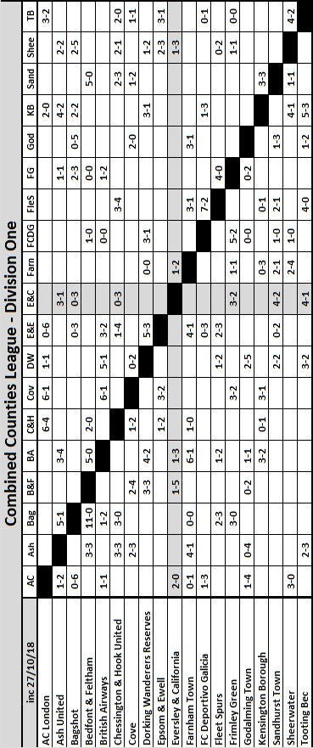

Club Statistical History - (including Chessington & Hook United (A) on 27/10/18):
League: Played: 2,936, Won: 1,202, Drawn: 559, Lost: 1,175
For: 5,399, Against: 5,216, GD: plus 183 - Win Ratio 40.94%

CCL only: Played: 515, Won: 228, Drawn: 101, Lost: 186
For: 933, Against: 830, GD: plus 103 - Win Ratio 44.27%

Cup and Other (inc Abandoned Matches):
Played: 1,121, Won: 530, Drawn: 130, Lost: 453 Abandoned: 8
For: 2,429, Against: 2,102, GD: plus 327 - Win Ratio 47.28%

Under Simon Funnell: Played 3, Won: 2, Drawn: 0, Lost: 1
For: 10, Against: 5, GD: plus 5 - Win Ratio 66.67%

Total: Played 4,057, Won: 1,732, Drawn: 689, Lost: 1,628, Aban: 8
For: 7,828, Against: 7,318, GD: plus 510 - Win Ratio 42.69%

First Senior Match: 30th August 1924.
Lost 1-3 vs Dorking at our home ground at the time of Horton Hospital Grounds.

First Match Programme Issued: 15th September 1923.
Won 4-0 vs West Norwood Reserves - Friendly match at Horton Hospital Grounds.

Number of Official Home Grounds: Six.

Alexandra Recreation Ground 1918-1922,
Horton Hospital Grounds 1922-1925,
West Street 1925-1993,
Merland Rise 1993-2010,
Moatside 2010-2012,
High Road 2012- present.

Record Win: 12/10/1935 - 13-1 v Reigate Priory (H) - Amateur Cup.

Record Defeat: 14/02/1948 - 0-14 v Chelmsford City Reserves (A) - London League.

Longest Serving Manager: 1) Adrian Hill 853 1982-1985 & 1990-2003
2) Pat O’Connell 466 1973-1982
3) Lyndon Buckwell 407 2006-2014
4) Ricky Kidd 190 1986-1990

Record Appearances: 1) Graham Morris 658 1990-2004
2) Nigel Bennett 630 1989-2005
3) Tommy Tuite 582 1973-1987
4) Ernie Watkins 419 1945-1960

Record Goal Scorers: 1) Tommy Tuite 391 1973-1987
2) Reg Marlow 254 1924-1936
3) Kyle Hough 207 2007-2017
4) Jimmy Jones 148 1933-1945

Most Appearances in a season: Tony Coombe and Tommy Tuite - 59 in 1980/81.

Most goals in a season: Reg Marlow - 65 (at least) in 39 appearances in 1926/27.

Senior League Titles: 5 - 1925/26 Surrey Senior League - 1926/27 Surrey Senior League - 1927/28 London League - 1974/75 Surrey Senior League - 1977/78 Isthmian League Division Two

Recent Milestones
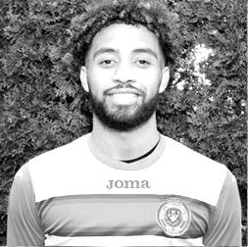
Congratulations go to Lloyd Connelly who made his fiftieth appearance on Wednesday 10th October in our 3-2 defeat at British Airways. Lloyd joined us last season, scoring on his debut at Camberley Town on 14th October, so to make fifty appearances in less than 12 months is an impressive achievement. He joined us from Westfield and has recently been converted to a defender, although this has coincided with an increase in his scoring return with four already this season, giving him six in total. So far each time he has scored we have avoided defeat, so let’s hope he keeps going! Lloyd is the 271st player to reach this mark for us, which might sound like a lot, but we have had close to 1,600 players in our history, so this is still a good number to reach and as he remains ever-present this season, who knows how many he could be on by the end of the year if he remains injury-free.

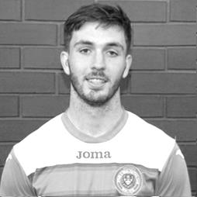
Nearly a couple of weeks later, on Tuesday 23rd October Liam Roberts made his own 50th appearance against Knaphill Under 23s at High Road. Liam joined us at the start of last season from the Leatherhead Academy and it is fair to say that there is a large amount of talent there, with some spectacular goals over his time with us. Liam has twelve so far for us from his 51 appearances and has potential to do even better. Equally adept on either wing, he is more usually to be found on the left, either cutting inside the defender or taking it around him.

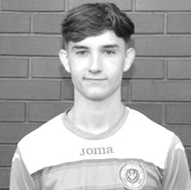
Finally, Adam Heagney should be making his 100th appearance this afternoon. Adam joined us back in August 2016 along with Jordan Gallagher from the Leatherhead Academy and both established their places in the starting line-up as we went on to finish in fourth place. When we lost many of our squad to Sutton Common Rovers including Gallagher, Adam chose to join Guildford City, but came back to us fairly quickly and has remained with us ever since.

Adam has proved to be a quite versatile player, starting with us as a right back, but has also played down the right flank and also at centre-half where his apparent calmness on the ball appears to give him more time. Nowadays he is operating in a holding defensive midfield role, but also provides many assists with some dangerous set pieces. He only has two goals for us so far, and one of those was a penalty, although his first goal for us in April 2017 against Knaphill came from well over thirty yards and flew into the top corner. It’s probably time for another one now!

Matches against Frimley Green F.C.
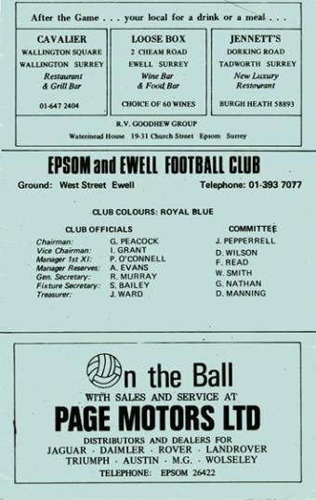
We have an excellent record against today’s opponents, with eight wins and a draw from our ten meetings and a goal difference of F32 v A5.

Our first meeting at Frimley Green Recreation Ground, although I believe, on a different site to the current ground, came on Saturday 10th November 1973 in a League Cup tie and we won 3-0 with two goals from Tommy Tuite and one from Dave Ritman, going on to lift the Cup in May of 1974. On the left is a programme from our first ever home League meeting just two weeks later when Frimley Green returned the compliment with a 1-0 win, although we then won 2-0 over there on 2nd February 1974 in the League with two Colin Rose goals.

We met once in 1982 when we were in superb form, although just a month away from the Pat O’Connell walkout that would change much at the club and in between County Cup wins over Hendon (London Senior) and Tooting & Mitcham United (Surrey Senior) we defeated Frimley Green 7-1 in a Southern Combination Cup tie that was switched to West Street as we had floodlights. Steve Hill got a hat trick that day with Tommy Tuite and Jeff Hunn scoring two each.

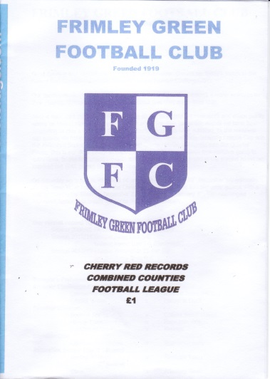
We then had to wait 26 years before our next meeting at Merland Rise in the F.A. Cup, where we prevailed 2-1 but not without a scare as we trailed at the half. Fortunately two Leon White goals saw us through; the second of which was a very brave header.

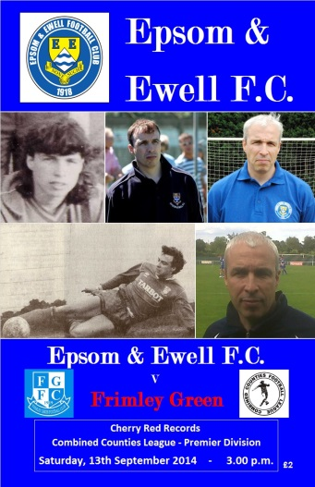
Our remaining five meetings came over two seasons while Frimley were in the Premier Division of the Combined Counties League. We won 3-0 at home and 5-1 away in 2013/14, and the following season we drew 0-0 at home and won 5-1 again in the League matches (see programmes) although we also won 5-0 in the League Cup Third Round that year at Frimley; a venue where we have a perfect record of five wins from five visits.

We now meet once again after a break of three seasons.

Combined Counties League – Division One
Saturday, 3rd November 2018 - Kick-off 3.00 p.m.
Epsom and Ewell  (Royal Blue & White hoops) | V |  | Frimley Green  (All Red)
Squad | NUMBERS |  | Squad
Conor Young |  |  | Harvey Stevens
Adam Heagney |  |  | Chris Harris
Reisse Griffin |  |  | Mark Primett
Lloyd Connelly |  |  | Zac Horkan
Steve Betancourt |  |  | Calum Nimmo
Ryan Sullivan |  |  | Abu Rayhan
Liam Roberts |  |  | James Ward
© Scott Murphy |  |  | Matthew Ward
Olly Martinez |  |  | Ben Dearlove
Elliott Thompson |  |  | Sam Hamer
Bobby Bennett |  |  | Cyrus Vanterpool
Rob Hendry |  |  | Leonel Medrado
Germaine Jeannoel |  |  | Jeffrey Vasquesz Roseo
Endrit Dobraj |  |  | Robert Jermain
David Jones |  |  | George Bowerman
Joshua Caulcrick |  |  | Tony Trinder
Taryn Smith |  |  | Eddie Mckinley
Alex McKay |  |  | Michael Lacey
Ricky Borrett |  |  | Dan Bone
George Gill |  |  | Sean Latimer
Scott Elgar |  |  | Kristian Cumberbatch
Simon Funnell | MANAGER |  | John Cook / Jamie Daltry
Sam Morgan | COACHES |  | Roland Baker / Steve Lynch / Jamie Harris
 | PHYSIO |  | Chelsea Goulter
REFEREE: D.Sheldrake
ASSISTANTS: R.Redman, J.Lidbetter
Today’s match is sponsored by
George, Joseph, Ezara and Inara Beddoe

OUR NEXT VISITORS TO HIGH ROAD
Sandhurst Town
Esoteric Combined Counties League Division One Cup – 2nd Round
Tuesday, 6th November 2018 – 7.45 pm

